Process Outline for Internship Packet Approval and Registration

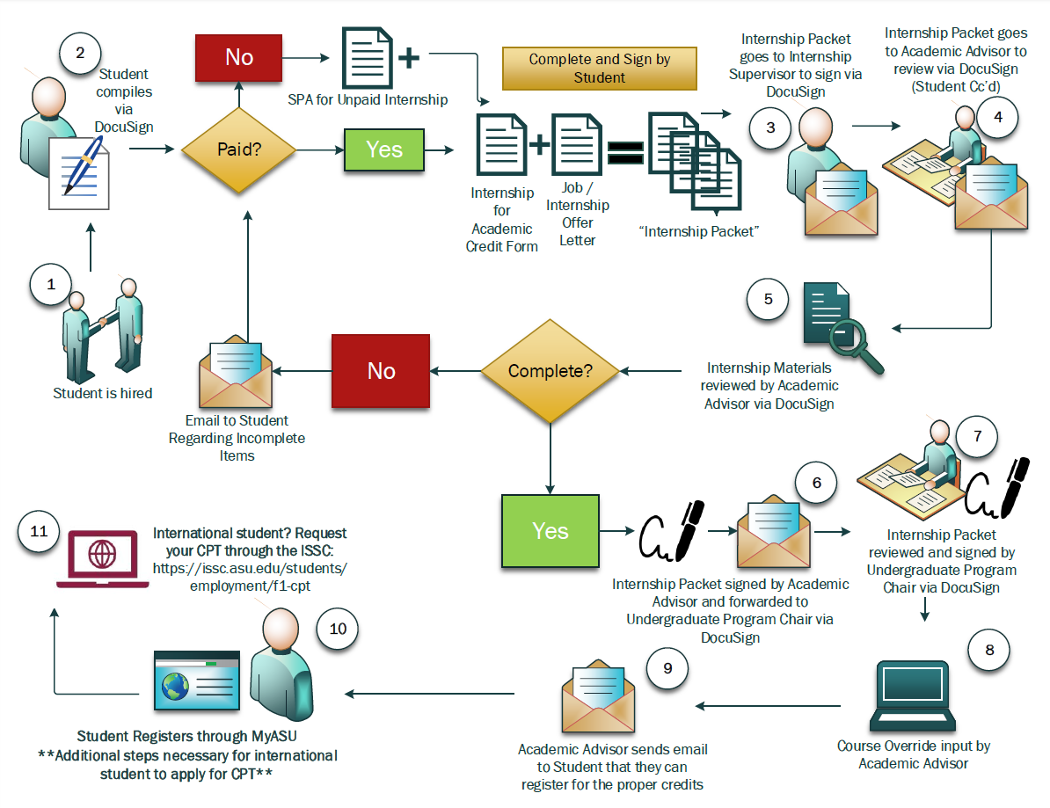

Before you proceed with the EEE 484 Internship Packet,
be sure you read the following information and have met the eligibility criteria.

Eligibility
The following defines the requirements for the student and internship position.
The student must have:
- GPA - Earned a cumulative ASU GPA of 3.0
- Be enrolled in your current degree program for a minimum of one academic year
- Must have Junior standing by completing all the courses in term 4 of your major map.
In addition,
- Students may use only a maximum of 2 credit hours of EEE 484 credit toward their degree requirements.

The position must:
- Be directly related to Electrical Engineering or Power Systems Engineering and require the background gained through major courses.
- The content of your internship must be approved by faculty as a technical elective
- Provide the intern with appropriate learning experiences to enrich his or her overall education.
- Be posted and/or advertised as an internship. Ongoing or permanent positions are not eligible.
- For international students doing CPT, the position must start on or after the first day of the semester
- Require the intern to work a maximum of 20 hours per week for 14 weeks during the fall or spring semesters or up to full time during the 8-week summer session.
- Have a designated supervisor/mentor who will provide feedback on the intern’s progress.

Deadlines to apply:
- Fall term requests must be received no later than July 20
- Spring term requests must be received no later than December 10
- Summer term requests must be received no later than April 15

Completion Process
A student will receive a grade (pass or fail) for EEE 484 if the following are completed:
- Semester report written by intern. The following as a minimum must be included:
  - Overview of primary focus.
  - List of significant outcomes.
  - Description how the internship contributed to the learning experience.
  - Signature by student’s supervisor assuring accuracy and ensuring no company sensitive information is compromised.

Arizona State University, Ira A. Fulton Schools of Engineering
School of Electrical, Computer and Energy Engineering
EEE 484 Internship

Application: Internship for Academic Credit

Internship Course Mission
This course is designed to provide undergraduate students an internship experience in relevant industry and related sectors that provides the intern direct exposure to real world professional activities, enhances their personal and professional skills, and increases the likelihood of professional employment opportunities in their major. In addition, students gain experience in resume development, how to prepare for and conduct themselves in a professional interview by company representatives and are better prepared to enter their chosen profession.

The School of Electrical, Computer, and Energy Engineering (ECEE) allows Electrical Engineering BSE students to complete a maximum of 2 semesters (or a semester and a summer) of paid or unpaid internship. Students can do this by taking 2 one credit hour EEE 484 Internship classes for academic credit.
**Please note that International students must apply to use CPT if approved for this internship. F1 visa students must have a physical presence on campus during the Fall or Spring semester. So, they must have an internship within the state of Arizona in fall or spring. In summer, international students may do internships out of state.

Process and Procedures
The EEE 484 internship course has a formal process to acknowledge a student’s proposed internship experience for academic credit. *Arizona Board of Regents (ABOR) states each unit of internship or practicum must require a minimum of forty-five (45) contact hours per unit of credit. Programs can set higher contact hour requirements. To receive academic credit for an internship experience, the student must complete the paperwork identified below, submit it for course registration review/approval, and then register for the course by the deadline listed on the Academic Calendar. For Curricular Practical Training (CPT), the student will need to submit the paperwork at least 2 weeks prior to the start of the semester and coordinate with the International Student and Scholars Center (ISSC) so that the internship start date can coincide with the start of the semester. All materials identified in this document are available for download at https://ecee.engineering.asu.edu/cpt-and-internship-information/

Steps to Registering

- Student is in good academic standing
Students who wish to receive academic credit for a future internship experience must be, at minimum, in good academic standing within their program and a current student of the Ira A. Fulton Schools of Engineering.
- The student is hired by a company to do work within their major’s scope.
Students must secure employment for the defined timeframe of the indicated semester. Employers must be a registered business and in good standing in the state in which the internship experience will take place. The company must be reputable and fall within the degree area in which the student is enrolled at Arizona State University.
- Fill out – Internship for Academic Credit Application Form
This core documentation describes the planned experiences and information about the employer. Attach additional pages, if needed. The student must consult with his/her supervisor and complete this document fully, by defining the intern’s role and responsibilities; specifying how they relate to the student’s degree, and how accomplishments and performance will be measured during the experience before submitting this form. Answer the following questions listed on the document in the position description:
- Where will the internship take place? If the internship is in multiple locations, list all the student’s work locations. If remote work is proposed, clearly write “remote work” and describe how supervision and feedback will be given during that time.
- Write, and/or attach, the expected job duties that the student will perform during the internship. This section should be a complete job description. A job description from the company can be attached if it fully defines the position and projects. Do not submit a single line descriptor as it will be rejected, delaying the approval process.
- Describe the specific applicability of the internship to the student’s academic program and how it will provide learning beyond the classroom. List specific tools, software, projects, activities, practical experience and professional skills that will be gained, applied, and how they supplement classroom learning.
- How will the company evaluate the student’s performance? Interns should fully understand the items that will be used to measure work performance during the internship. Performance metrics might be aligned directly with the job description. The company may use additional performance metrics. Describe the process with which the company will evaluate the intern’s performance. Will it be a formal evaluation form or a sit-down discussion? Interns have a right to know how the end of the internship evaluation will take place. If this was not identified in the hiring process, the intern is advised to speak with the supervisor. In addition to any internal evaluation, students are required to write a report following the template and prompts found in this packet. The industry supervisor must sign off on the report. Students are required to submit the report to their assigned academic advisor.
- The supervisor’s signature. The supervisor’s signature affirms the internship description is accurate; affirms that the learning objectives are agreed upon by the employer and student; and, that the related deliverables are acknowledged and approved. If the packet is incomplete or lacks clarity in the job description the academic unit will return materials to the student to provide more information. It is best to provide as much information about the internship experience to avoid delays in the review process.
- Combine the registration request form, employer form, and job offer.
After completing the registration request form, attaching the employer letter, and the offer letter, the combined materials are considered the “internship packet”.
- Submit the completed paperwork to your assigned academic advisor via email.
The student submits the signed internship packet to their assigned academic advisor at least 2 weeks prior to the start of the internship. Incomplete submissions will be returned, halting the review process until the student provides the completed documents. F1 visa students using the internship course for Curricular Practical Training (CPT), must submit the paperwork by at least 2 weeks prior to the start of the semester to ensure the student can enroll in the course.

If the internship meets academic requirements and the paperwork is complete and approved, the assigned academic advisor will sign the course registration request form and send to the Undergraduate Program Chair if necessary.
- Upon receipt of the Undergraduate Program Chair’s signed paperwork, the student will be cleared by his/her academic advisor to register for the internship course. The student’s academic advisor will email the student when packet is complete and the student is able to register.
- Student registers for the internship course. It is the student’s responsibility to ensure he/she is registered in the appropriate course and section. Use the ASU academic calendar page to verify late registration fee deadlines, as well as drop/add for each session - https://students.asu.edu/academic-calendar. Standard tuition and fees apply.
- Student fills out the ISSC eform (if the student is international). It is the student’s responsibility to complete the ISSC eform and list their assigned academic advisor (with the correct email address) in the eform. International students will not receive an updated I-20 without this.

Questions? Please contact your assigned academic advisor.

School/College:
Internship Course: Credit Hours:

INTERNSHIP FOR ACADEMIC CREDIT APPLICATION FORM

STUDENT INFORMATION

Last Name: | First Name: |  | 10 Digit ASU Student ID #:
ASU Email Address: |  |  | Phone Number:
Major: |  |  | Degree:
Expected Graduation Date: |  | Internship Semester:
Overall Cumulative GPA: | Total # Credits Completed: |  | Total # of credits remaining after internship:

COMPANY INFORMATION

Company Full Legal Name:
Street Address: |  |  |  |  | City:
State: | Zip Code: |  |  | Country:
Supervisor First & Last Name: |  | Supervisor’s Email Address: |  |  | Supervisor’s Phone Number:
Supervisor’s Title: |  |  | Internship Title:
Internship Start Date: |  |  | Internship End Date:
Expected # Work Hours per Week: |  |  | Expected Total # Work Hours for Internship:
Paid Position? Yes No |  | Salaried Position? Yes No |  |  | Stipend? Yes No
Hourly Pay Rate: |  | Working remotely? Yes No
Mode of Supervision:[Choose items that apply]
In-person Virtual Conference Email Telephone
Frequency of Supervision: [Choose items that apply]
Daily Weekly Monthly As needed

INTERNSHIP LOCATION AND DESCRIPTIVE CONTENT

List all physical address(es) where the student will work.
List the expected job duties that the student will perform during the internship.

Describe or attach the specific applicability of the internship to the student’s academic program and how it will provide learning beyond the classroom. How does it relate to the student’s major?
Describe or attach how the company will measure/evaluate the student’s efforts to meet the performance metrics?

Offer Letter/ISSC CPT Employment Information Letter

Domestic students: Please upload your offer letter here.

International students: Attach the ISSC CPT Employment Information letter. The template can be found here: https://issc.asu.edu/sites/default/files/cpt_info_sheet.pdf

UNPAID SPA, IF NEEDED
Student: If the internship is UNPAID, attach the Unpaid SPA confirmation email. Follow the process at https://career.engineering.asu.edu/spa.

STUDENT FERPA RELEASE AND AFFIRMATION OF RESPONSIBILITY

- Student: I understand that by completing this form, I am releasing the listed FERPA data in this packet to the company where I will intern.

- Student: I meet all requirements and pre-requisites to enroll in the internship course.

- Student: I have read the syllabus and understand the course requirements.

- Student: I have spoken with my supervisor, who agrees to conduct a performance evaluation and (if applicable) to review any other assignments.

- Student: It is my responsibility to submit the supervisor’s evaluation (if applicable) of me and any other course requirements to ASU by the course’s listed due dates.

- Student: I have attached my signed offer letter to this document.

- Student: I understand that if a course override is granted, it is my responsibility to register for the internship course by the deadline.

International Students

- Student: If I am an international student, I understand it is my responsibility to contact the
International Student and Scholars Center to submit all required work authorization paperwork by their deadline.

Student: Please sign.

Student Signature: | Date:

ISSC Formatted CPT Letter

Placeholder for ISSC CPT Formatted Offer Letter

The letter must be on official company letterhead and signed by employer.

Download letter template from ISSC CPT page: https://issc.asu.edu/students/employment/f1-cpt.
EMPLOYER SUPERVISOR INSTRUCTIONS AND GUIDELINES
The School of Electrical, Computer, and Energy Engineering (ECEE) considers the student internship requirement to be a critical element in the degree experience. Though it is not mandatory, we strongly encourage our students to learn the roles and expectations and develop skills to be productive employees during their internships. Positive internship experiences often result in the student’s full-time employment by the sponsoring company following graduation.

The objective of the internship program is to ensure that every student has meaningful exposure within their degree area, and to provide every student with a challenging work experience that enhances the classroom experience and exposes the student to “real world” means and methods.

The internship should be 1) approved prior to registration and 2) prepares the student, in a significant way, for professional work within their specific degree.

ECEE is committed to minimal demand on the time and resources of industry employers. Though it is not mandatory, the internship is a curriculum requirement and it is the Department’s responsibility to verify that the student has successfully completed the requirement. Therefore, the ECEE will require that the student obtain the signature of the employer’s internship supervisor on this document and a final evaluation based on the provided rubric. Companies are encouraged to make comments about the student’s performance and areas of improvement on the internship assessment form. Students will submit a self-evaluation to the department as well.

- Supervisor: By signing I agree that the student will be mentored/supervised within my company by an appropriately qualified person related to the student’s major, during the dates stipulated in the internship dates section above and that the description of the expected duties of the internship is accurate.

- Supervisor: I agree that if a student must be released early from the internship due to business needs, I will contact the student’s academic advisor to inform them and provide an evaluation of the student’s work up until the point of the student’s release.

- Supervisor: I agree to submit an evaluation of the student’s performance based on the rubric provided.

Employer Supervisor Signature: | Date:
Typed Name of Supervisor:

ASU Internal Routing: Please sign.

By signing, the assigned academic advisor affirms that the internship application and all required materials have been received and approved. The student is now eligible to enroll in the internship course.
Academic Advisor Signature: | Date:
Name:

By signing, the Undergraduate Program Chair approves that the student is approved to use EEE 484 on their DARS.
Undergraduate Program Chair Signature: | Date:
Name:

ISSC – CPT Approval for I-20 Work Authorization

Curricular Practical Training (CPT) work authorization is a two-step process. The first part is registering for curricular component that is met by the EEE 684 Internship course. The second part is applying to ISSC for I20 modification to work off campus. The CPT process is outlined on the ISSC website at https://issc.asu.edu/employment/students-fj/f-1-cpt. Your academic advisor will be contacted to verify the internship experience. It is important that the job offer letter submitted in the internship packet be exactly the same as the job offer letter submitted to ISSC.

EEE 484 Final Report
Year:
Semester:

Student Information
Name:
ASU ID:

Industry Mentor Information
Name:
Company Name:
Email:
Phone Number:

--------------------------- ----------------
Industry Mentor’s Signature Date

--------------------------- ----------------
Student Signature Date

--------------------------- ----------------
Program Chair Signature Date

A Passing grade on this internship report is required to receive credit. The report should be concise but thorough and include the following information:

ABSTRACT
Summary of the project and results. (<200 words)
INTRODUCTION
Brief background, outline of the project, its motivation, the experimental methods and the contributions.
WORK ENVIRONMENT
Short description. Include any useful observations or problems to aid a future extension.
If there is significant background (theory, implementation, equipment, facilities), use separate subsections or sections.
RESULTS
Include (or describe) results, measurements etc. Explain how the observations meet the original expectations. If contradicted, formulate a new theory or hypothesis to be tested. Any claims should be supported by a quantitative and specific analysis of the observed results.
CONCLUSIONS
Brief summary of observations, implications, and future directions.
REFERENCES
- K. Tsakalis, “EEE 480 Lab Experiments,” http://www.eas.asu.edu/~tsakalis/coursea/lab.pdf, Arizona State University, Aug. 2001.
- Franklin, Powell, Emami-Naeini, Feedback Control of Dynamic Systems, 3rd Ed., Addison Wesley, 1994.
- G. Strang, Linear Algebra and its applications. 2nd Ed. Academic Press, NY, 1980.

